**Project Design Phase-II**

**Technology Stack (Architecture & stack)**

|  |  |
| --- | --- |
| **Date** | 15 October 2022 |
| **Team ID** | PNT2022TMID49677 |
| **Project Name** | IOT Basd Safety Gadget Child Monitoring and notification |
| **Maximum Marks** | 4 Marks |

**Technical Architecture**:

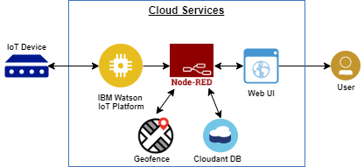

## Table 1:Components and technologies:

|  |  |  |  |
| --- | --- | --- | --- |
| S.No | Components User Interface | Description How user interacts with application e.g. Mobile App ,etc | Technology GPS ,GSM |
| 1. | Application Logic-1 | Logic for a process in the application | Python –Raspberry pi |
| 2. | Application Logic-2 | Logic for a process in the application | IBM child safety kit |
| 3. | Application Logic-3 | Logic for a process in the application | IBM kid security |
| 4. | Database | Data Type, Configurations etc. | Crate DB |
| 5. | Cloud Database | Database Service on Cloud | IBM Cloud ant DB |
| 6. | File Storage | File storage requirements | IBM Watson Studio ,IBM Cloud |
| 7. | External API-1 | Purpose of External API used in the application | IBM Weather API etc. |
| 8. | External API-2 | Purpose of External API used in the application | IBM Cloud etc. |
| 9. | Infrastructure(server or cloud) | Application deployment for local system or cloud | Cloud database server |

### Table2: Application Characteristics:

|  |  |  |  |
| --- | --- | --- | --- |
| **S. No •** | Characteristics | Description | Technology |
| 1. | Open source architecture | * Framework is presented for Smart child safety using Sensor network and IOT. * The Key feature of the system are Deployment of smart sensor For the collection of Data,cloud based analysis And decision based on Monitoring for children Safety. | Technology used is Big data,cloud,IOT,AI. |
| 2. | Scalable Architecture | * The collected values from every sensor like temperature sensor, pulse rate detection sensor, metal detection sensor, and the location value from GPS are used to detect the status of the child and alerts the respective guardians using GSM accordingly. | Technology used is sensors and GPS technology,for monitoring children activities. |
| 3. | Availability | * The availability of sensors and their working progress will happen always even in the absence of parents controlling. | Technology used is effective through recording. |